create database SQLCodebasetest

use SQLCodebasetestDB

create table Books(

BookID int primary key,

BookTitle varchar(20),

BookAuthor varchar(20),

Bookisbn varchar(20),

PublishedDate date)

insert into Books values(1, 'My First SQL Book','Mary Parker', '981483029127', '22-FEB-2012'),

(2, 'My Second SQL Book','John Mayer', '857300923713', '03-July-1972'),

(3, 'My Third Sql Bokk', 'Cary Flint', '523120967812', '18-Dec-2015')

create table reviews(

Id int,

BookID int foreign key references Books(BookID),

ReviewerName varchar(20),

Content varchar(20),

Rating int,

PublishedDate date)

insert into reviews values(1, 1, 'John Smith', 'My First Review', 4, '10-Dec-2017'),

(2, 2, 'John Smith', 'My Second Review', 5, '13-OCT-2017'),

(3, 2, 'Alice Walker', 'Another Review', 1, '22-OCT-2027')

select \* from Books

select \* from reviews

--Write a query to fetch the details of the books written by author whose name ends with er.

select \* from Books Where BookAuthor like '%er';

--Display the Title ,Author and ReviewerName for all the books from the above table

SELECT B.BookTitle, B.BookAuthor, R.ReviewerName

FROM Books B

INNER JOIN reviews R ON B.BookID = R.BookID;

--Display the reviewer name who reviewed more than one book.

SELECT R.ReviewerName

FROM reviews R

GROUP BY R.ReviewerName

HAVING COUNT(DISTINCT R.BookID) > 1;

create table customer

(

CustID int primary key,

CustName varchar(20),

CustAge int,

CustAddress varchar(30),

CustSalary decimal,

)

insert into customer values(1, 'Ramesh', 32, 'Ahmedabad', 2000.00),

(2, 'Khilan', 25, 'Delhi', 1500.00),

(3, 'Kushik', 23, 'Kota', 2000.00),

(4, 'Chaithali', 25, 'Mumbai', 6500.00),

(5, 'Hardik', 27, 'Bhopal', 8500.00),

(6, 'Komal', 22, 'MP', 4500.00),

(7, 'Muffy', 24, 'Indore', 10000.00)

create table orders(

OID int,

Date date,

CustID int foreign key references customer(CustID),

Amount decimal)

insert into orders values(102, '08-OCT-2009',3, 3000),

(100, '08-OCT-2009',3, 1500),

(101, '20-NOV-2009',2, 1560),

(103, '20-MAY-2009',4, 2060)

select \* from customer

select \* from orders

--Display the Name for the customer from above customer table who live in same address which has character o anywhere in address

SELECT CustName FROM customer

WHERE CustAddress LIKE '%o%';

SELECT \* FROM customer

WHERE CustAddress LIKE '%o%';

--Write aquery to display the Date,Total no of customer placed order on same Date .

SELECT Date, COUNT(DISTINCT CustID) AS TotalCustomers

FROM orders

GROUP BY Date

HAVING COUNT(DISTINCT CustID) > 1;

SELECT Date, COUNT(DISTINCT CustID) AS TotalCustomers

FROM orders

GROUP BY Date

ORDER BY Date;

create table Employee

(

EMPID int primary key,

EMPName varchar(20),

EMPAge int,

EMPAddress varchar(30),

EMPSalary decimal,

)

insert into Employee values(1, 'Ramesh', 32, 'Ahmedabad', 2000.00),

(2, 'Khilan', 25, 'Delhi', 1500.00),

(3, 'Kushik', 23, 'Kota', 2000.00),

(4, 'Chaithali', 25, 'Mumbai', 6500.00),

(5, 'Hardik', 27, 'Bhopal', 8500.00),

(6, 'Komal', 22, 'MP', null),

(7, 'Muffy', 24, 'Indore', null)

select \* from Employee

--Display the Names of the Employee in lower case, whose salary is null

SELECT LOWER(EMPName) AS 'LowerCase Name'

FROM Employee

WHERE EMPSalary IS NULL;

Output Screenshots:

1)Write a query to fetch the details of the books written by author whose name ends with er.

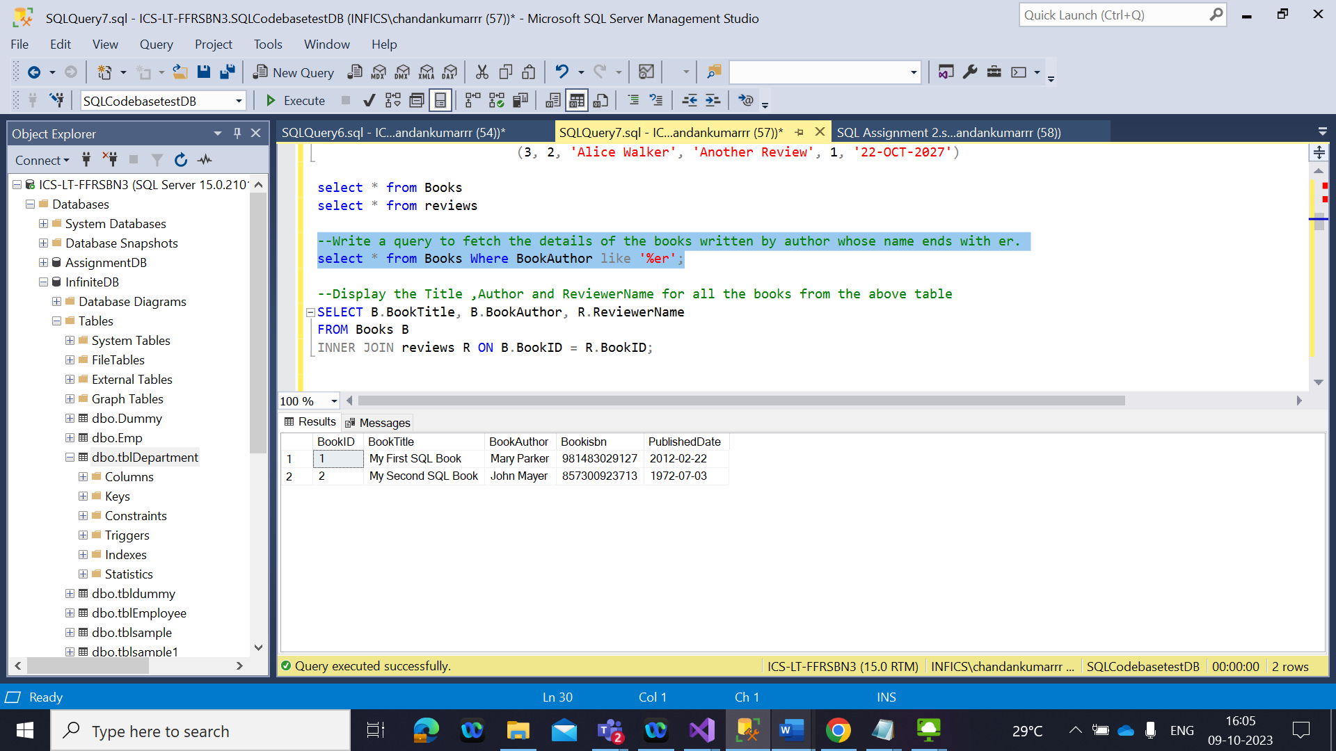

2) Display the Title ,Author and ReviewerName for all the books from the above table.

3) Display the reviewer name who reviewed more than one book.

4) Display the Name for the customer from above customer table who live in same address which has character o anywhere in address

5) Write a query to display the Date,Total no of customer placed order on same Date

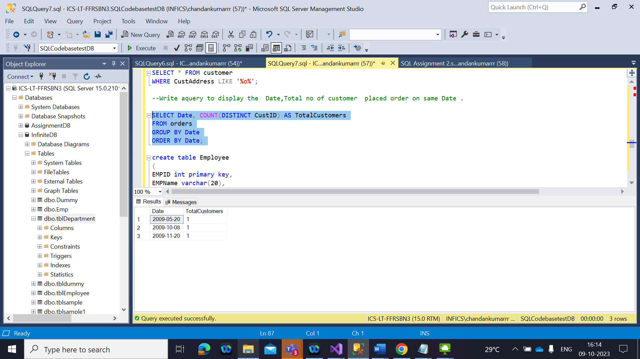

6) Display the Names of the Employee in lower case, whose salary is null

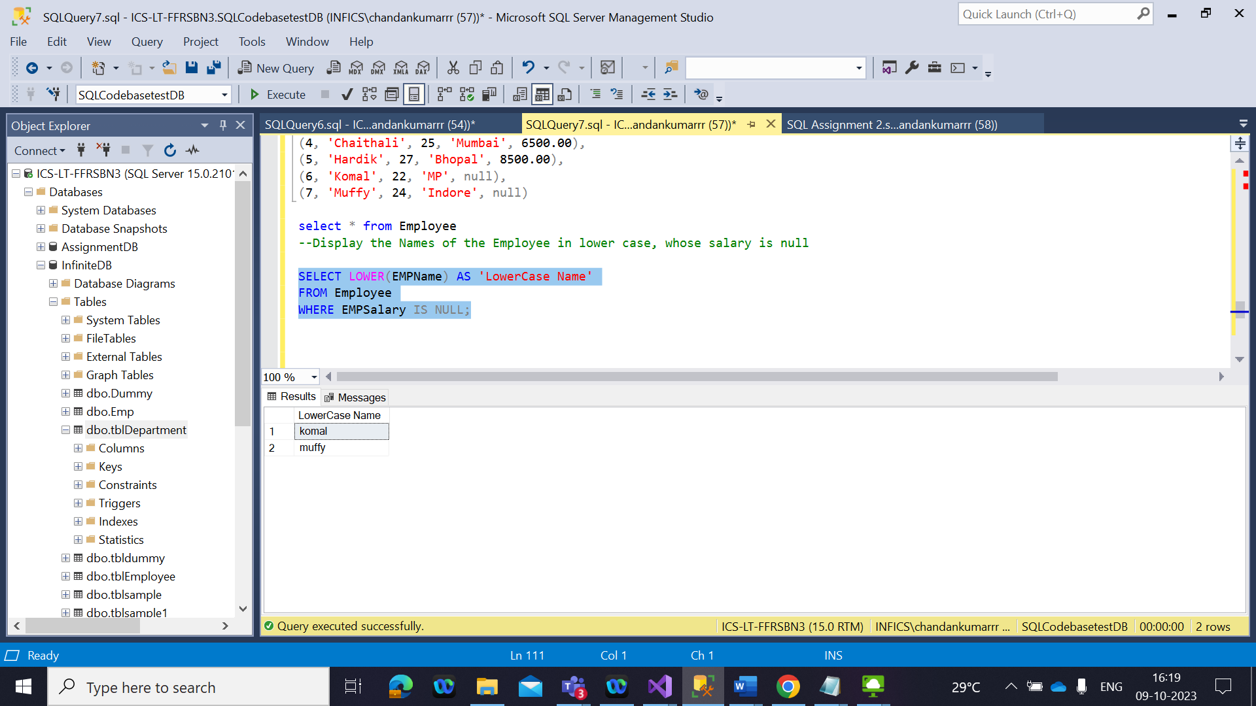

7) Write a sql server query to display the Gender,Total no of male and female from the above total

SELECT Gender, COUNT(\*) AS 'Total'  
FROM Studentdetails  
GROUP BY Gender;